Come fly with me!

*Book your own trip to the United Kingdom!*



Travel Agency name: Britt & Iris Travel Center

Group Members:

1. Iris Haasjes. Class: T3A
2. Britt Heusinkveld. Class: T3A

The assignment

Dag allemaal,

De bedoeling van het project is, dat jullie in alleen of met z’n tweeën, een reis gaan uitstippelen voor twee personen. De reis gaan jullie uitzoeken op Engelse websites van de aangegeven vliegtuigmaatschappijen, hotels met Engels ontbijt en je zoekt 6 activiteiten voor de reis. Zorg dat de tijd van de vlucht en de datum op elkaar aansluiten, dus dat beide aankomstdagen hetzelfde zijn. Jullie krijgen hiervoor een bepaald bedrag waar je **niet** overheen mag! De duur van de reis is een mid-week, dus 5 dagen.

Jullie geven voorbeelden en bewijs van de opgezochte informatie via print screen. Deze print screen plakken jullie achter de juiste opdracht (vluchten bij opdracht vliegtuigmaatschappijen ect.) Je begint met het invullen van het samenwerkingscontract en het verdelen van de taken bij het kopje takenverdeling. Van daar uit werk je het boekje door. Als je alleen werkt, schrijf je een plan van aanpak wanneer je wat gaat doen.

Uiteindelijk lever je het boekje in bij de docent en presenteer je de reis voor de klas met een PowerPoint.

**Hoe is dit project verdeeld?**

*Les 1: Korte introductie van je docent over de opdracht. Vervolgens ga je met jullie*

*groep aan de slag met het projectboekje. Je gaat beginnen met een*

*plan van aanpak maken, de taken verdelen en een start met de opdrachten.*

*Les 2: Opzoeken van informatie/verder werken aan de opdrachten.*

*Les 3: In deze les gaan jullie de presentatie in elkaar zetten, je maakt gebruik van een*

*PowerPoint of Prezi.*

*Hierna volgen de PRESENTATIES!*

*De presentatie is minimaal 3 minuten, maximaal 6. Als je met twee personen bent, verdeel je de presentatie evenredig.*

*In je presentatie staan (minimaal) de vluchten, het hotel en de activiteiten.*

*Aan het einde van de les vullen jullie de evaluatie in.*

|  |
| --- |
| **INFORMATIE MET BETREKKING TOT DE REIS**  **De reis wordt geboekt op een maandag en de terugvlucht op vrijdag:**   * 17 oktober t/m 21 oktober 2016 * 24 oktober t/m 28 oktober 2016   **Het bedrag dat jullie krijgen om uit te geven is:**   * **€ 2000,-**   **Aantal dagen:**   * Mid-week, dus 5 dagen * 4 overnachtingen |

Samenwerkingscontract groep

**Namen + Mail adressen:**

Iris Haasjes – [irishaasjes@gmail.com](mailto:irishaasjes@gmail.com)

Britt Heusinkveld – [heusinkveldb@gmail.com](mailto:heusinkveldb@gmail.com)

**Groepsregels:**

***Wat doen jullie bij afwezigheid of ziekte van jullie groepsgenoot of jezelf?***

Gewoon veder werken en later bespreken wat je gedaan hebt.

***Wat doe je bij onenigheid/ruzie in jullie groepje?***

Samen een oplossing proberen te zoeken / het goed maken.

***Hoe gaan jullie het werk verdelen? (+tijdsplanning)***

Samen dingen opzoeken en taken eerlijk verdelen, allebei even veel doen.

***Hoe blijf je van elkaars werk op de hoogte?***

Via de app of real life (na school thuis afspreken)

***Wat doen jullie als je iets niet snapt?***

Uitleg vragen op school of een email sturen

Plan van Aanpak Individueel

**Naam + E-mailadres:**

---------------------------------------------------------------------------------------------------------------------------------------------------------------------------------------------------------------------------------------------------------------------------------------------------------------------------------------------------------------------------------------------------------------------------------------------------------------------

**Afspraken richting docent:**

***Wat doe je bij afwezigheid of ziekte?***

---------------------------------------------------------------------------------------------------------------------------------------------------------------------------------------------------------------------------------------------------------------------------------------------------------------------------------------------------------------------------------------------------------------------------------------------------------------------

***Hoe gaan je het werk verdelen? (+tijdsplanning)***

---------------------------------------------------------------------------------------------------------------------------------------------------------------------------------------------------------------------------------------------------------------------------------------------------------------------------------------------------------------------------------------------------------------------------------------------------------------------

---------------------------------------------------------------------------------------------------------------------------------------------------------------------------------------------------------------------------------------------------------------------------------------------------------------------------------------------------------------------------------------------------------------------------------------------------------------------

***Wat doe je als je iets niet snapt?***

---------------------------------------------------------------------------------------------------------------------------------------------------------------------------------------------------------------------------------------------------------------------------------------------------------------------------------------------------------------------------------------------------------------------------------------------------------------------

Taakverdeling

|  |  |  |  |  |
| --- | --- | --- | --- | --- |
| **Taak.** | **Wie?**  (nvt bij individueel) | **Wanneer af?** | **Benodigdheden?** | **Gedaan?** |
| Opdracht 1 | Beide | 10 juni | Websites  Google maps | Ja |
| Opdracht 2 | Beide | 10 juni | Websites  Google maps  Valuta omrekenen | Ja |
| Opdracht 3 | Beide | 16 juni | Websites  Google maps |  |
|  |  |  |  |  |
|  |  |  |  |  |
|  |  |  |  |  |
|  |  |  |  |  |
|  |  |  |  |  |
|  |  |  |  |  |
|  |  |  |  |  |
|  |  |  |  |  |
|  |  |  |  |  |
|  |  |  |  |  |
|  |  |  |  |  |

A trip to Great Britain!



Opdracht 1: Vluchten bekijken, uitkiezen

Opdracht 2: Hotels bekijken, uitkiezen

Opdracht 3: Uitzoeken, kiezen en beschrijven activiteiten

Opdracht 4: Presentatie! PowerPoint maken/rolverdeling presenteren

3 minuten minimaal, maximaal 6.

+ Persoonlijke evaluatie

Assignment 1: Choose your destination and book your flight

**Opdracht: Come fly with me**A TRIP TO THE UK

You will be acting as a travel agent. Either by yourself or together you will be planning a trip to Great Britain. The obvious place would be London. However, I also dare you to look beyond London.

With every assignment you complete, you will notify your teacher. This means that after ‘Opdracht 1’ you will reflect back to me that you completed it and whether you have any questions or not. After ‘Opdracht 2’ the same, and so on.

You all bare responsibility for the tasks ahead. This means, that if you are working together with someone who is not pulling their weight, you have to inform me in a timely manner. If I figure out you have not done what you are supposed to do on hindsight, I will not be able to support you.

And for now…. Good luck!

Follow below steps:

**Step 1:**

Go to the website below:

<http://www.easyjet.com/en/>

**Step 2:**

Find your flights (example)

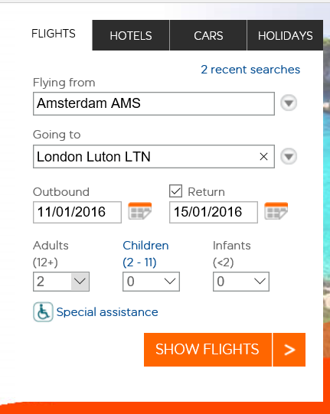

**You will find out what a return flight will cost to your chosen destination in the UK.**

* **You will fly from Amsterdam (AMS) to >your destination in the UK<**
* **Double check you have the correct dates**
* **The ticket is for two adults**
* **You have to book your flight from the Monday morning to the Friday afternoon**
* **Choose your best option**
* **Don’t forget to print screen!**

**Stap 3:**

**Ensure you write down all the details of the flight including showing your printscreen. Think about times, dates, prices, luggage and any additional things you might want to add.**

|  |
| --- |
| Details flights:  Yay! We’ve decided to go to Edinburgh!  **Monday October 24th**  The plane leaves at 13:15 Central European Time, In Amsterdam (Schiphol)  The plane lands at 13:45 Greenwich Meantime +1, in Edinburgh Airport  **Friday October 28th**  The plane leaves at 18:40 Greenwich Meantime +1, in Edinburgh Airport  The plane lands at 21:15 Central European Time, in Amsterdam (Schiphol)  **Prices**  The prices for both the flights includes €188,18 (back and forth)  **Luggage**  Each passenger is entitled to bring ONE cabin bag up to a maximum size of 56x45x25cm including handles and wheels. Excess weight can be purchased. On our flight there’s no hold luggage added.  Right after we land in Edinburgh we go to our bed and breakfast, and around 3 PM we can pick up our hire car. It’s a Fiat. The car costs €26,55 each day, we rent the car for 5 day so that means it’s €132,75 for 5 days.  **The sum of money (flight & the hire car) = €320,93**  ………………………………………………………………………………………………..  ………………………………………………………………………………………………..  ………………………………………………………………………………………………..  ………………………………………………………………………………………………..  ………………………………………………………………………………………………..  ………………………………………………………………………………………………..  ………………………………………………………………………………………………..  ………………………………………………………………………………………………..  ………………………………………………………………………………………………..  ………………………………………………………………………………………………..  ………………………………………………………………………………………………..  ………………………………………………………………………………………………..  ………………………………………………………………………………………………..  ………………………………………………………………………………………………..  ………………………………………………………………………………………………..  ………………………………………………………………………………………………..  ………………………………………………………………………………………………..  ………………………………………………………………………………………………..  ………………………………………………………………………………………………..  ………………………………………………………………………………………………..  ………………………………………………………………………………………………..  ………………………………………………………………………………………………..  ………………………………………………………………………………………………..  ………………………………………………………………………………………………..  ………………………………………………………………………………………………..  ………………………………………………………………………………………………..  ………………………………………………………………………………………………..  ………………………………………………………………………………………………..  ………………………………………………………………………………………………..  ………………………………………………………………………………………………..  ………………………………………………………………………………………………..  ……………………………………………………………………………………………….. |

Assigment 1: Print Screen Flights

Please paste your print screen of your flight information below

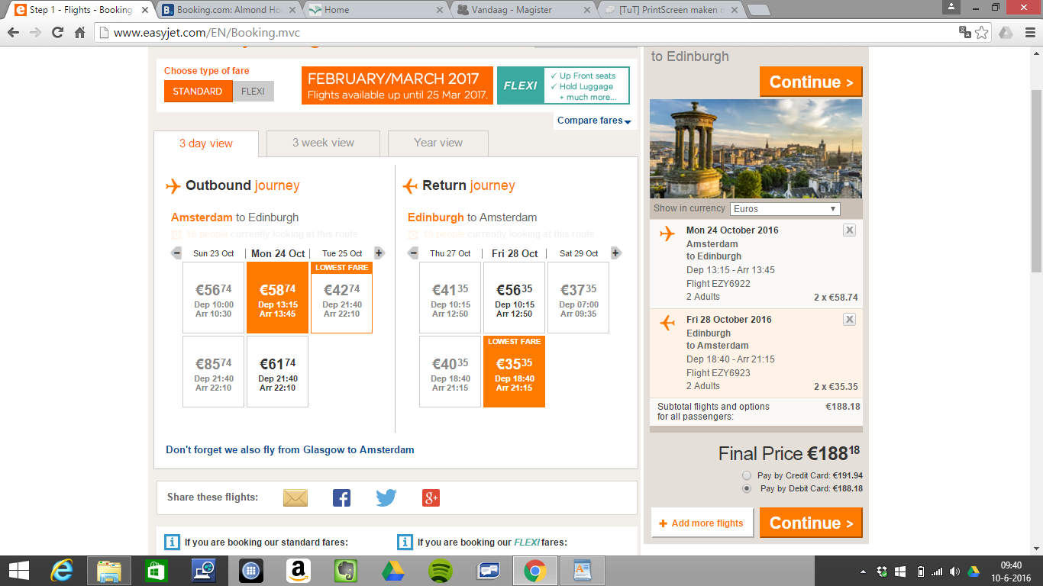

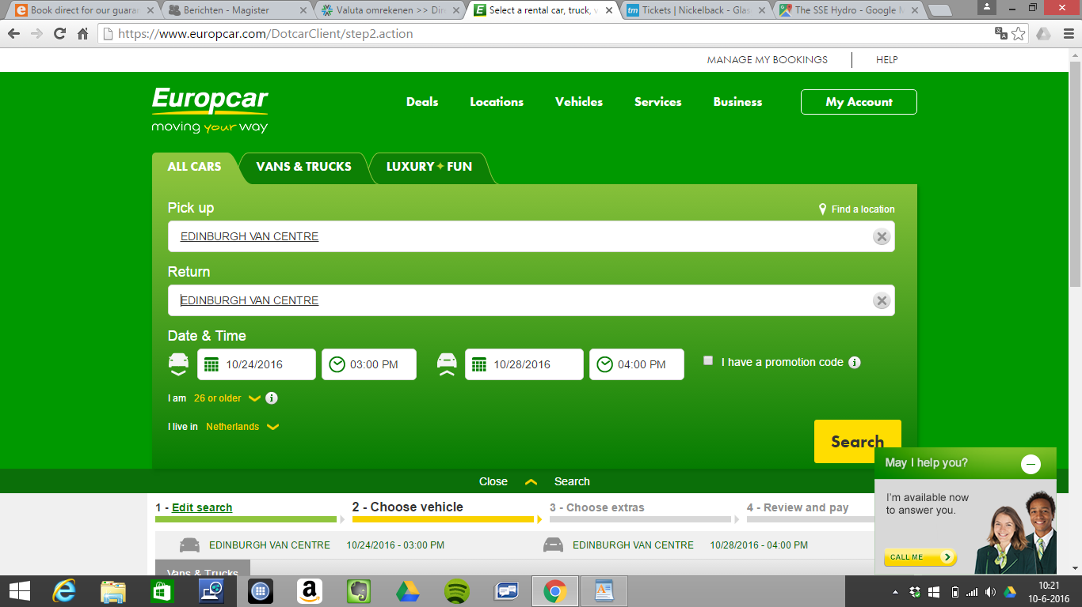

Assignment 2: Book your stay

**Step 4:**

**In your previous assignment, you have chosen your flights to your destination. On top of going there, you will need a place to stay.**

**The minimum requirements are:**

* **It has to be one accommodation for the 4 nights you are there**
* **You need to include breakfast**
* **It has to be within your budget**
* **It has to have come from an English website**

**Tips for accommodation websites:**

* [**http://www.bedandbreakfasts-uk.co.uk/**](http://www.bedandbreakfasts-uk.co.uk/)
* [**http://www.bedandbreakfastnationwide.com/**](http://www.bedandbreakfastnationwide.com/)
* [**http://www.hotels.uk.com/**](http://www.hotels.uk.com/)
* **If you were to find another English website, that is allowed. Make sure you state your source!**

**Stap 5:**

* Write down the details of your accommodation, including dates, prices and facilities

|  |
| --- |
| Accommodation details:  **Adress:** Aaron Glen Guesthouse  7 Nivensknowe Road, Loanhead, Midllothian  EH20 9AU  **Breakfast:**  The breakfast includes: Fruit juices, fresh fruits, cereals, yoghurt, cheese and oatcakes.  Full Scottish breakfast: farm eggs, smoked bacon, sausages. Fresh mushrooms with vine tomatoes, tattie scone, potatoes, haggis, black pudding and baked beans.  **The bedroom:**  The bedroom includes: a shower, plenty of hot water, fresh towels supplied every day. Large comfortable beds, flat screen television, a hairdryer in every room and free wifi.  **The sum of money for 4 nights = €351,76**  ………………………………………………………………………………………………..  ………………………………………………………………………………………………..  ………………………………………………………………………………………………..  ………………………………………………………………………………………………..  ………………………………………………………………………………………………..  ………………………………………………………………………………………………..  ………………………………………………………………………………………………..  ………………………………………………………………………………………………..  ………………………………………………………………………………………………..  ………………………………………………………………………………………………..  ………………………………………………………………………………………………..  ………………………………………………………………………………………………..  ………………………………………………………………………………………………..  ………………………………………………………………………………………………..  ……………………………………………………………………………………………….. |

Assignment 2: Accommodation

Please paste your print screen of your accommodation information below

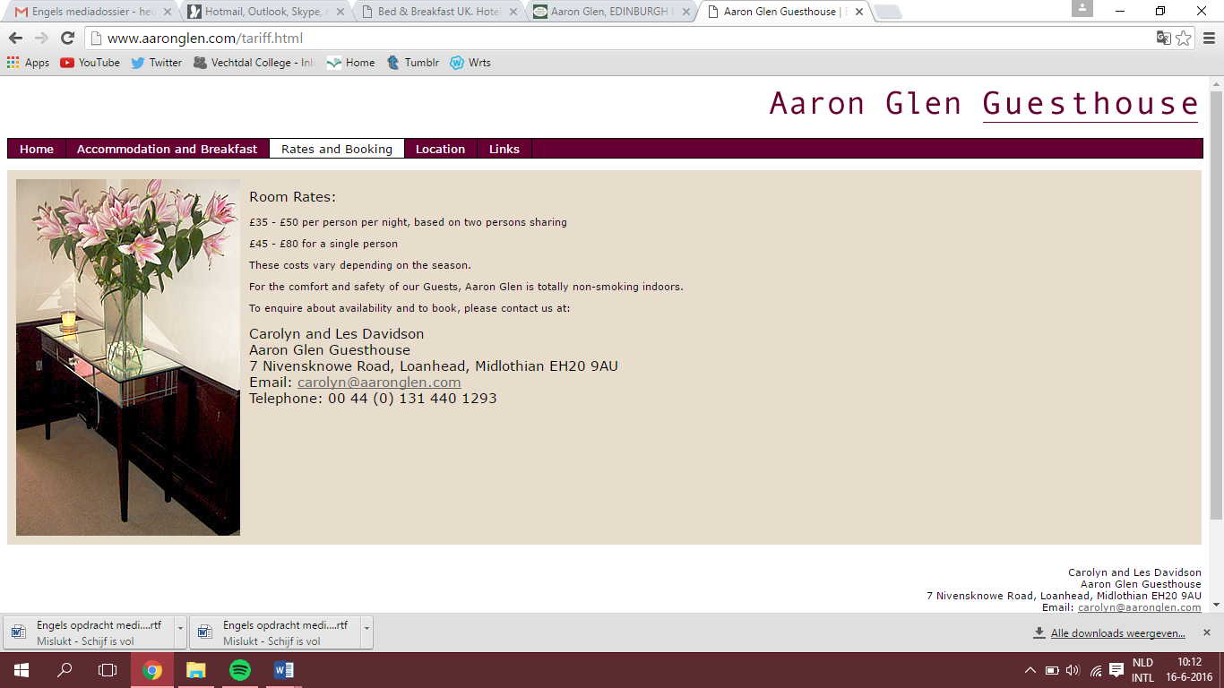

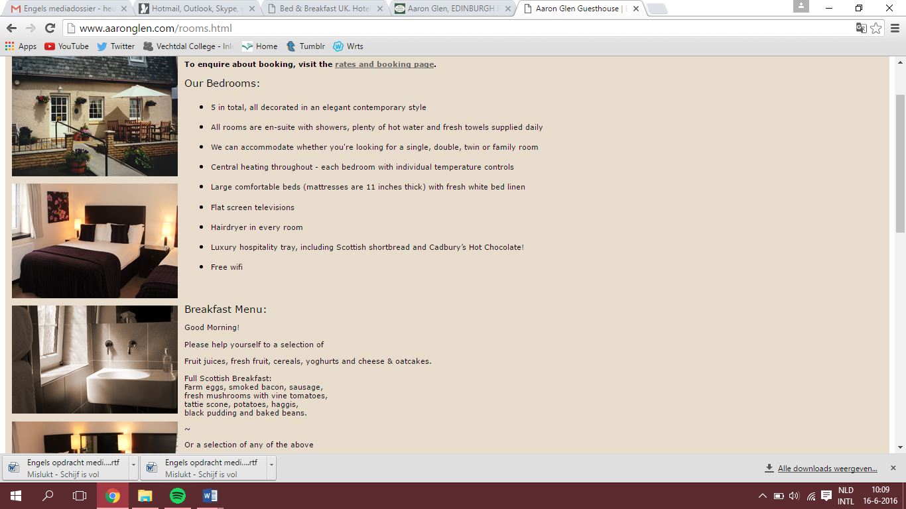

Assignment 3: What to do?

**Stap 6:**

You have booked your stay! Congratulations! However, you are a busy bee and would like to do something when you are there. After your arrival you will have to find a few activities. Please read below.

* **Day 1 (Monday):** your day of arrival. You will have a walk around your accommodation

and you will have to find a restaurant to eat at.

* **Day 2 (Tuesday):** visit to 1 activity
* **Day 3 (Wednesday):** visit to 1 activity
* **Day 4 (Thursday):** visit to 1 activity
* **Day 5 (Friday):** today is the end of your short break. See if you have any money and time left to do something.

**Please note!**

You are not allowed to visit the same activity twice!

**Activities could include:**

* Musea
* Events
* Gigs
* Theatre
* Anything the local ‘tourist office’ has to offer
* Any activity you would like to do whilst on holiday

**Be creative!**

|  |  |
| --- | --- |
| Day 1 | Activity: Nickelback concert.  Place: Glasgow.  Description: We’ve decided to go to a concert on our very first day in Edinburgh, well actually we’re going to Glasgow to see them. The concert starts around half past 7 but we are going to eat before the concert..………………………………………………………..  ………………………………………………………..  ………………………………………………………..  ……………………………………………………….. |
| Day 2 | Activity: Spa Bannatyne.  Place: Edinburgh.  Description:  Since we’re having quite a busy day on Monday we’ve decided that we’re going to chill out in the spa on Tuesday. We choose the lava wellness full body massage with consult. ………………………………………………………..  ………………………………………………………..  ………………………………………………………..  ……………………………………………………….. |
| Day 3 | Activity: Edinburgh castle.  Place: Edinburgh.  Description: We are going to Edinburgh castle. It’s a historic fortress which dominates the skyline of the city. It’s Scotland’s most-visited paid tourist attraction. The castle has become a recognizable symbol. |
| Day 4 | Activity: Edinburgh zoo.  Place: Edinburgh.  Description: On day 4 we’ve decided to go to the Edinburgh zoo, the zoo in Edinburgh was the first one to house and breed penguins. |
| Day 5 (optional) | Activity: Afternoon tea for two.  Place: Edinburgh.  Description: On the last day we’ve decided to do something more relaxed. That’s why we choose to have a afternoon tea. |

Assigment 3: Activities

Please paste your print screens of your activities information below

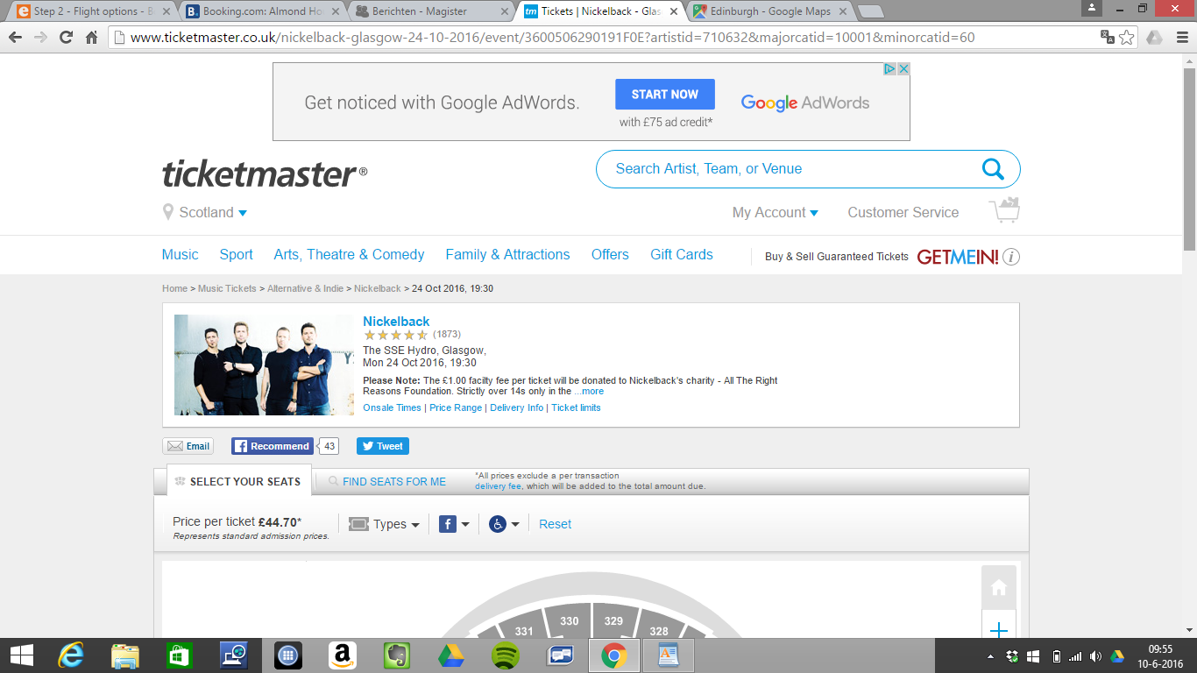

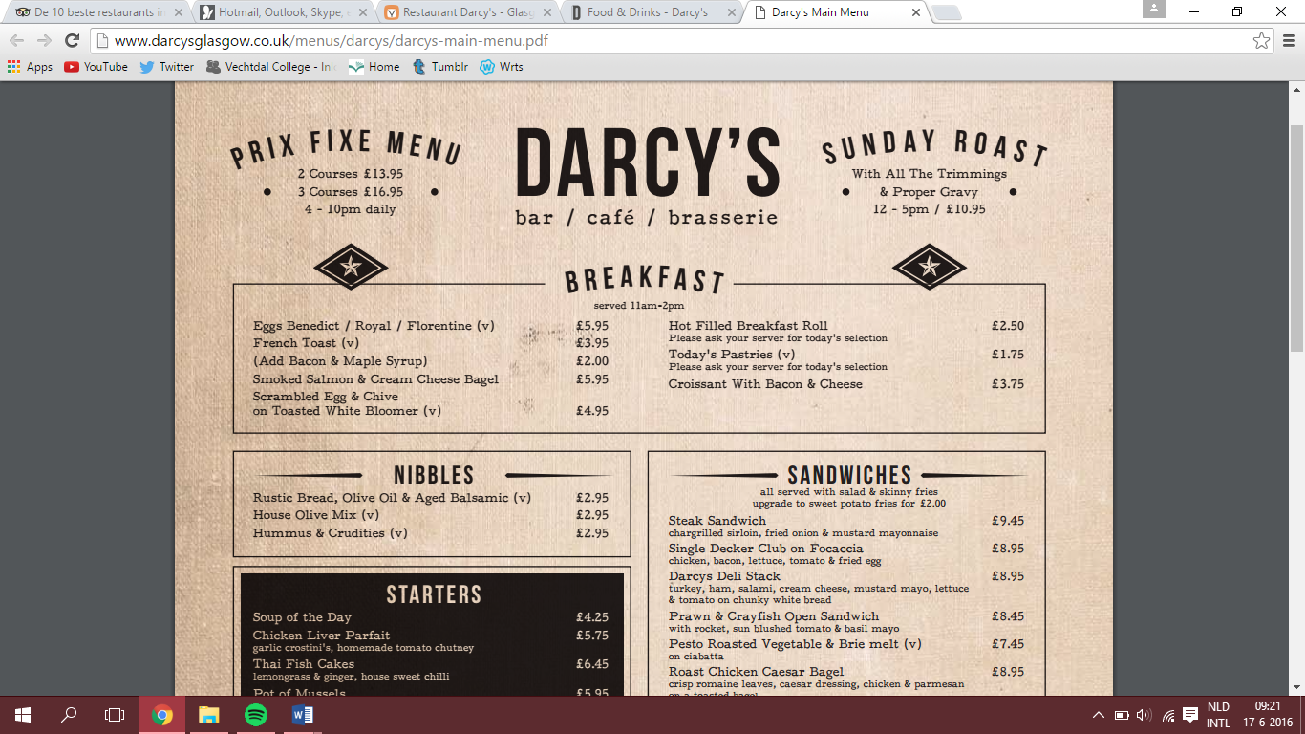

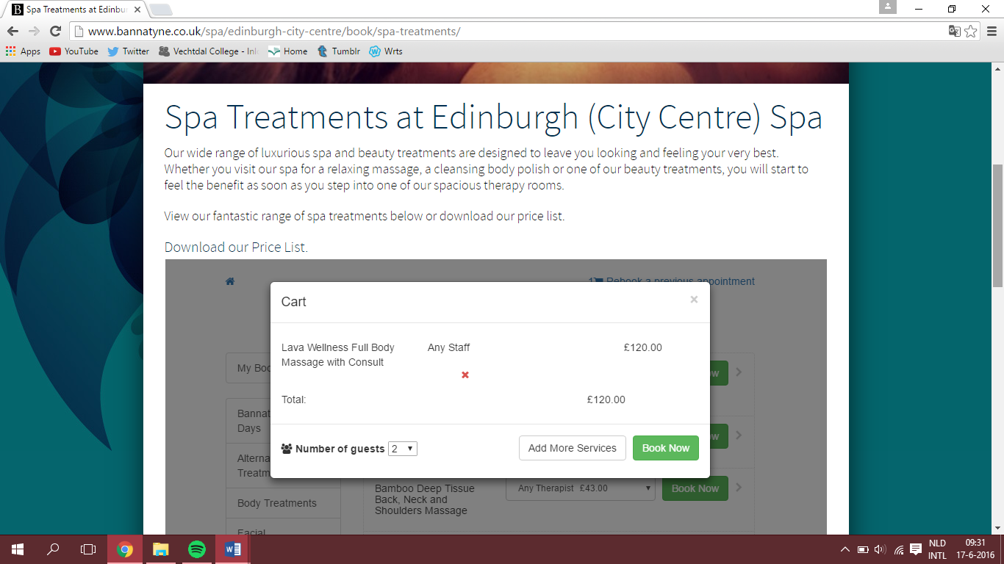

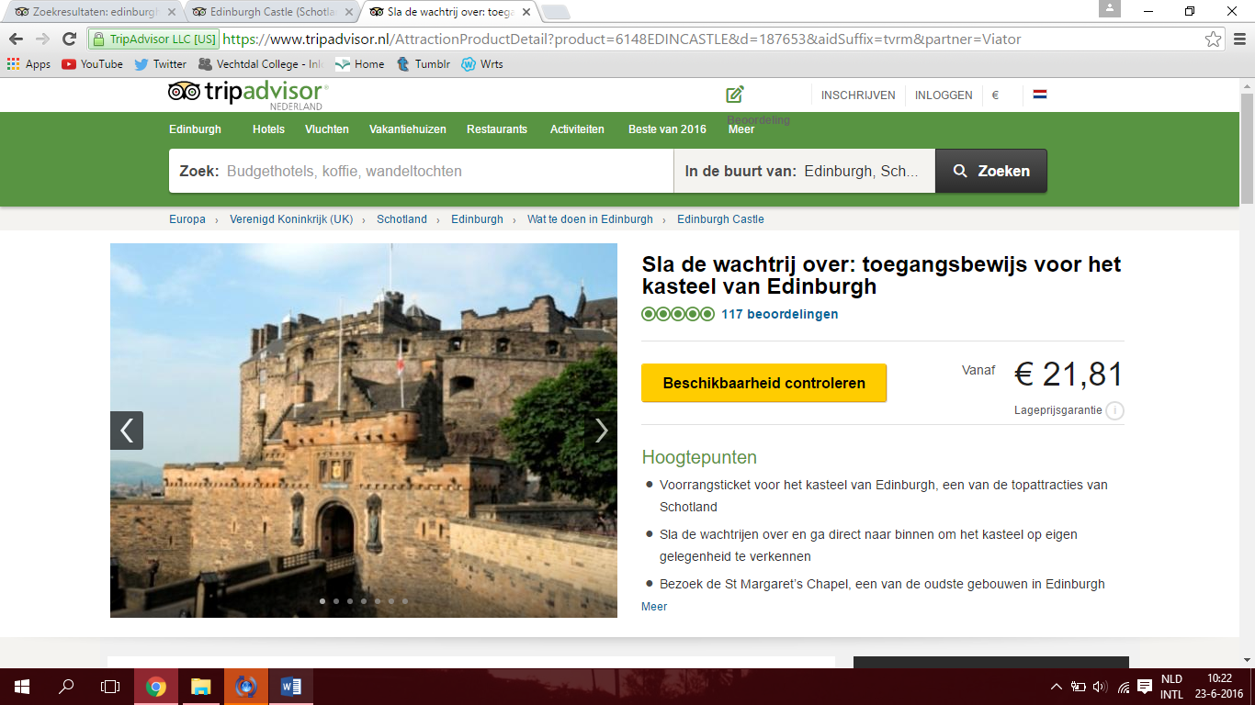

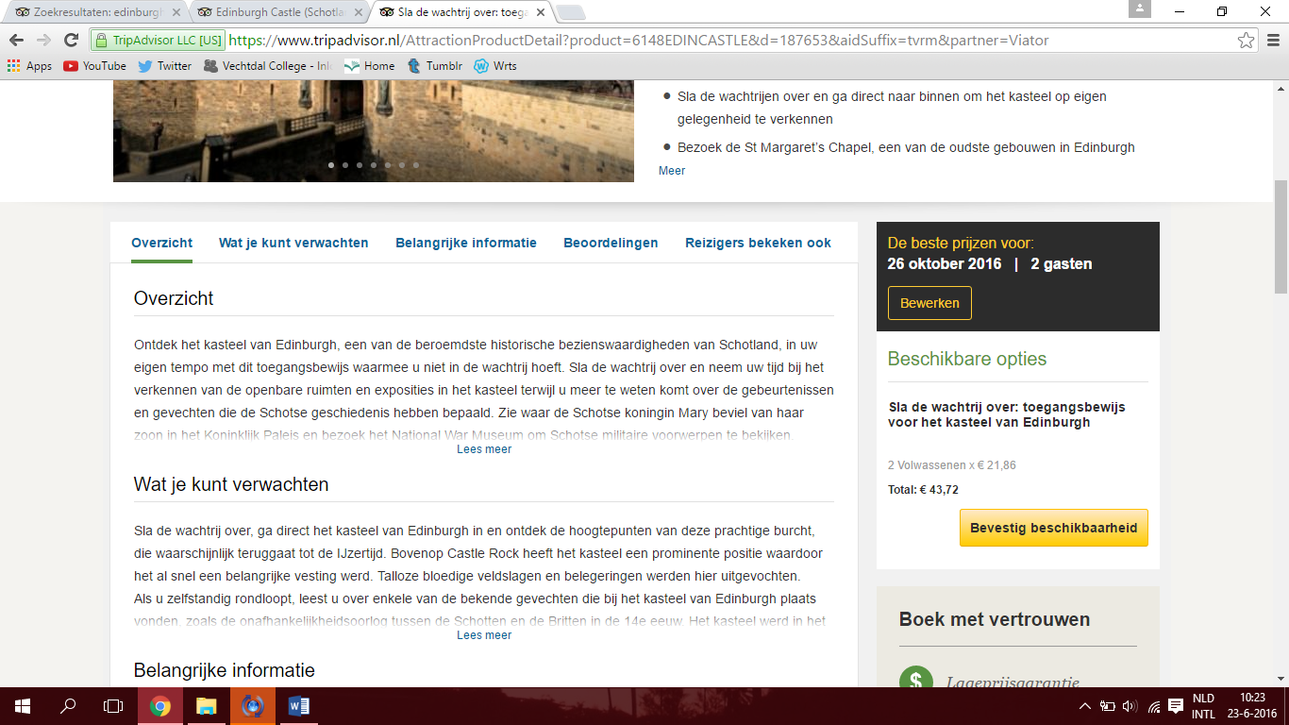

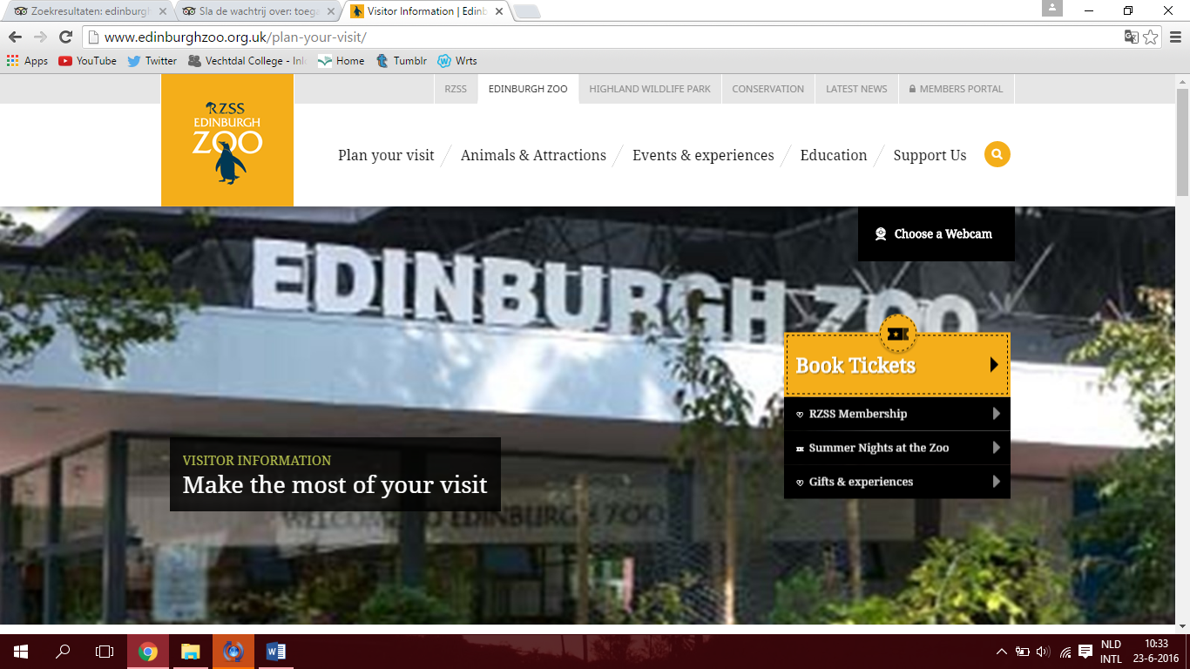

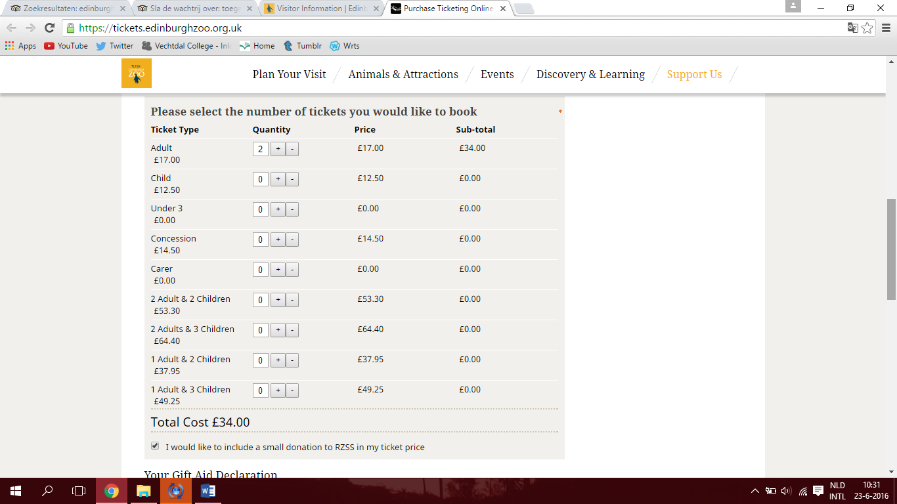

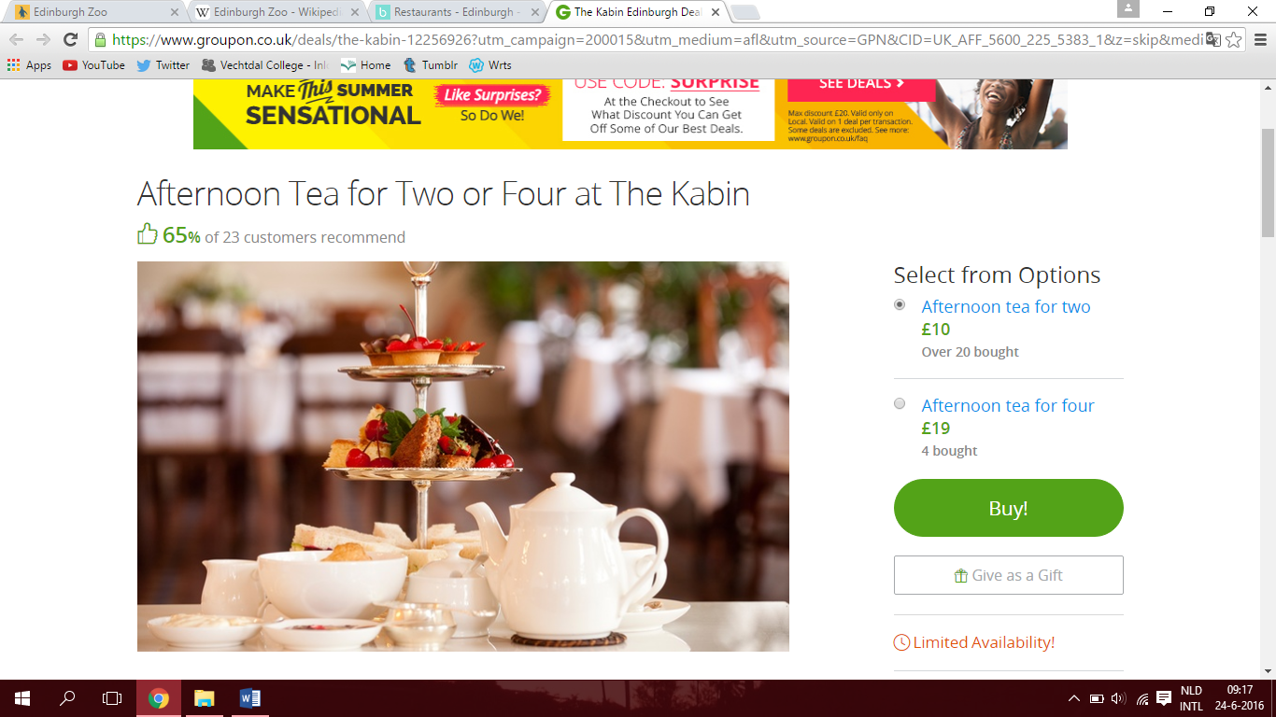

Assigment 4: Presentation

**Step 7:**

All of your information will now be gathered in a PowerPoint Presentation. Ensure it is a detailed description of your stay in the UK. And yes, it has to be in English.

Any questions, you know where to find me or email me via ELO/Magister.

Assignment 5: Personal Evaluation (pupil 1)

Name: Iris Haasjes.

Teacher: Miss. Klomp.

Date: 24-6-16.

**The tasks I contributed were:**

We have done this project together, so I haven’t done something all by myself.

**This is my opinion about the task and end result. Please explain**.

I’m very happy with the results. Everything went well and we agreed with everything.

**If you worked independent, please tell me what you found easy/hard/or what stood out for you.**

**If you worked together, please explain what you found easy/hard/or what stood out for you.**

Everything went really easy. But finding some activities was the hardest thing. But we have all the activities now and I’m very happy.

**Give yourself a grade on a scale from 1 to 10 about the full project.**

Naam: Iris Haasjes 1 2 3 4 5 6 7 **8** 9 10

**What did you think about the project and what could improve it?**

I really like this project. You are learning and seeing new things. School has to make this trip reality.

Please grade the project assignments:

A trip to the UK! 1 2 3 4 5 6 7 8 **9** 10

Assignment 5: Personal Evaluation (pupil 2)

Name: Britt.

Teacher: Miss. Klomp

Date: June 24th 2016

**The tasks I contributed were:**

Actually we worked together in everything so there isn’t a thing I did on my own. Except we both tried to find activities.

**This is my opinion about the task and end result. Please explain.**

I’m very happy with the end results, I think we’ve planned such a nice trip. And it isn’t very expensive as well.

**If you worked independent, please tell me what you found easy/hard/or what stood out for you.**

**If you worked together, please explain what you found easy/hard/or what stood out for you.**

It was kind of hard to find the activities, there were a lot of nice things you can do in the area. We tried to stay original.

**Give yourself a grade on a scale from 1 to 10 about the full project.**

Naam: Britt Heusinkveld 1 2 3 4 5 6 7 **8** 9 10

**What did you think about the project and what could improve it?**

I think the project is a nice thing to do, you’re both learning and doing. It’s fun because you’re not learning words or sentences from a book, you’re searching the information all by yourself.

I think there’s one thing that could be improved: Making this trip reality!!

**Please grade the project assignments:**

A trip to the UK! 1 2 3 4 5 6 7 8 **9** 10